**The BEST Dark and Rich Gluten-Free Chocolate Cupcakes**

[Adapted from Elizabeth Barbone's recipe at Serious Eats](http://www.seriouseats.com/recipes/2010/06/one-bowl-gluten-free-chocolate-cake-recipe.html)

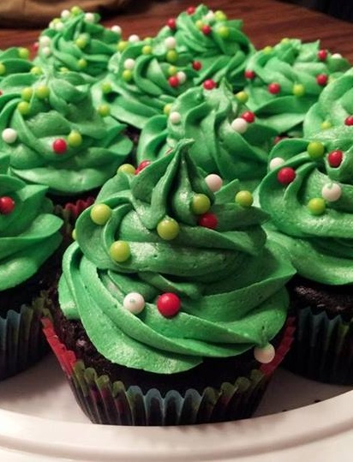Yield: 12-14 cupcakes. Recipe can be doubled.

**Ingredients:**

* 3/4 cup + 2 Tblsp of Gluten-Free Geeked-Up Flour Blend
* 1 cup sugar
* 1/2 cup cocoa
* 3/4 teaspoon baking powder
* 3/4 teaspoon baking soda
* 1/2 teaspoon salt
* 1/2 teaspoon xanthan gum (not needed for wheat flour...this takes the place of gluten)
* 1 egg
* 1/2 cup milk
* 1/2 cup vegetable or canola oil
* 1 teaspoon vanilla extract
* 1/2 cup warm water or coffee

**Directions:**

Preheat oven to 350 degrees and line a 12-well muffin tin with paper liners.

In a large bowl combine the sugar, flour blend, cocoa, baking powder, baking soda, salt and xanthan gum. Mix well.

Add the egg, milk, oil, vanilla extract and water (or coffee). Mix until smooth. Divide evenly among the prepared muffin wells.

Bake for 18-20 minutes, or until a toothpick inserted in the center comes out clean. Cool completely and top with your favorite frosting.

Note: recipe can be doubled. See link in comments to see the original recipe (which uses rice flour, cornstarch and sweet rice flour) and baking times for two 8-inch round cakes or one large 9x13 pan.

A good vanilla buttercream frosting is the classic [Wilton Buttercream](http://www.wilton.com/recipe/Buttercream-Icing#.Ux4_s_ldVYU).

If using coloring that is not a Wilton Gel add the coloring in place of some of the liquid. Even a touch too much liquid will make runny frosting :(

In the above recipe the Crisco can be replaced with more butter. The Crisco is good for warmer days because crisco is more solid at warmer temperatures. For the same reason margarine should not be used at all. Must be butter or butter/Crisco combo.